INCLUDE YOUR TITLE HERE. ALL LETTERS IN UPPERCASE. ARIAL FONT. FONT SIZE 14 AND BOLD

A. B. C. Surname^{1*} , D.E.F. Surname² , G.H.I. Surname³
¹First Institute Name, Country.
² Second Institute Name, Country.
³Third Institute Name, Country.

Abstract

Include your abstract here. Font: Arial (11 pts, regular) and limit your abstract to 300 words. Justified alignment.

Extended Abstract

- Introduction

Include the introduction here. Arial (11 pts, regular). Justified alignment. This formatting should be followed for all the sections below including reference list except for the titles. Titles should be of same font style (Arial) but 12 pts and in bold style.

- Methodology

Include the Methodology here.

- Results and Discussion

Include results and discussion here. Table titles and Figure captions must be as shown below

Table 01. Ionic conductivity and diffusivity of the gel polymer electrolytes.

Electrolyte | Ionic conductivity (x 10⁻³ S cm⁻¹) | Diffusivity of triiodide ions (x 10⁻⁶ cm² s⁻¹)
EC/PC | 2.9 | 3.9
EC/PC/TBP | 3.3 | 7.0
DMF/DCM | 1.3 | 0.7
DMF/DMSO | 1.9 | 1.0
DMF/DMSO/TBP | 2.3 | 2.5

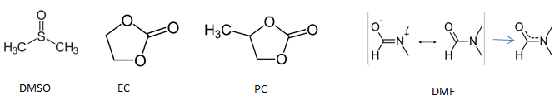

Fig. 1: Chemical structures of commonly used electrolytes

- Conclusions

Provide your conclusion here. After this include the references in Harvard style and limit to a maximum of 5 key references.

References
Aksakal, B. et al. (2016) ‘Effect of UV-light on the uniaxial tensile properties and structure of uncoated and TiO2 coated Bombyx mori silk fibers’, Spectrochimica Acta - Part A: Molecular and Biomolecular Spectroscopy, 152, pp. 658–665. Available at: https://doi.org/10.1016/j.saa.2015.01.131.
Aoki, J.I. et al. (2016) ‘Characterization of a Novel Endoplasmic Reticulum Protein Involved in Tubercidin Resistance in Leishmania major’, PLOS Neglected Tropical Diseases, 10(9), p. e0004972. Available at: https://doi.org/10.1371/journal.pntd.0004972.

